You have a binary tree with a small defect. There is **exactly one** invalid node where its right child incorrectly points to another node at the **same depth** but to the **invalid node's right**.

Given the root of the binary tree with this defect, root, return *the root of the binary tree after****removing****this invalid node****and every node underneath it****(minus the node it incorrectly points to).*

**Custom testing:**

The test input is read as 3 lines:

* TreeNode root
* int fromNode (**not available to**correctBinaryTree)
* int toNode (**not available to**correctBinaryTree)

After the binary tree rooted at root is parsed, the TreeNode with value of fromNode will have its right child pointer pointing to the TreeNode with a value of toNode. Then, root is passed to correctBinaryTree.

**Example 1:**

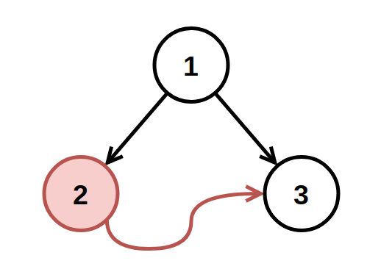

**Input:** root = [1,2,3], fromNode = 2, toNode = 3

**Output:** [1,null,3]

**Explanation:** The node with value 2 is invalid, so remove it.

**Example 2:**

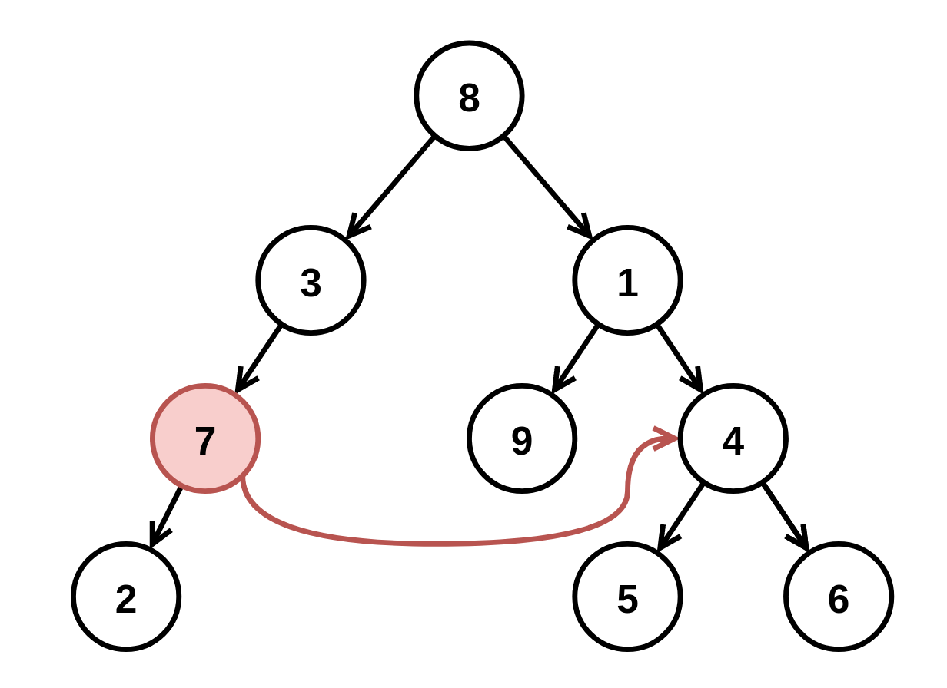

**Input:** root = [8,3,1,7,null,9,4,2,null,null,null,5,6], fromNode = 7, toNode = 4

**Output:** [8,3,1,null,null,9,4,null,null,5,6]

**Explanation:** The node with value 7 is invalid, so remove it and the node underneath it, node 2.

**Constraints:**

* The number of nodes in the tree is in the range [3, 104].
* -109 <= Node.val <= 109
* All Node.val are **unique**.
* fromNode != toNode
* fromNode and toNode will exist in the tree and will be on the same depth.
* toNode is to the **right** of fromNode.
* fromNode.right is null in the initial tree from the test data.